P245/4
CHRISTIAN RELIGIOUS
EDUCATION
(Christian Approaches
to Ethical and Ethical
Issues)
Paper 4
Jul / Aug 2018
2 ½ Hours
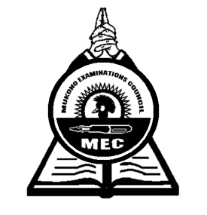

MUKONO EXAMINATIONS COUNCIL
Uganda Advanced Certificate of Education
CHRISTIAN RELIGIOUS EDUCATION
(Christian Approach to Social and Ethical Issues)
Paper 4
2 Hours 30 Minutes

INSTRUCTIONS TO CANDIDATES
This paper consists of three sections; A, B and C.
Candidates must answer four questions, with at least one question from each section.
All questions carry equal marks.
Any additional question(s) answered will not be marked.

SECTION A
SEX, MARRIAGE AND FAMILY

- a) How did the traditional African Society handle the period of adolescent among the
children?
b) Analyze the role of the Church in helping the adolescents in Uganda today?

- a) Examine the reasons why Christians denounce safer sex as an option for preventing
HIV/ AIDS.
b) What steps has the Church taken to fight the scourge of AIDS?

- a) What were the men’s attitude towards women in Traditional African Society?
b) Discuss the Biblical teaching on the ideal relationship between man and woman.

- a) Account for the existence of extended families in Traditional African Society.
b) Why are extended families dying out today?

SECTION B
WORK, LEISURE AND MONEY

- a) Discuss the traditional African attitude towards work.
b) What is the Biblical teaching on work?

- a) Discuss the factors which have led to the decline in the working ethics in Uganda today.
b) What advise do you give workers who are under-paid?

- a) “In the past there was no special time for leisure” Comment.
b) Analyze the problems associated with leisure today.

- a) As a Christian, examine the consequences of greed for money.
b) Examine the biblical teaching on the acquisition of wealth.

SECTION C
LAW AND ORDER
- a) Discuss the factors responsible for the increasing lawlessness in the world today.
b) Why is it necessary for the Christians to obey the law of his/her country?

- a) “ Mob Justice is a form of justice that criminals in society deserve.” Discuss the
statement as a Christian.
b) How can a Christian morally justify punishment of criminals?

- a) Justify the violation of children’s rights in Uganda today.
b) How is the Church in Uganda promoting respect for children’s rights?

- a) Analyze the conditions for a just war in the country.
b) Discuss the Christian position on war.

END

